Undergraduate Assessment Plan Overview

Summary
The new undergraduate curriculum assessment will take place over a two-year cycle. A two-year cycle was selected to minimize the time to results while emphasizing a realistic workload for teaching faculty and the undergraduate studies committee tasked with collecting and reviewing assessment data. With a two-year assessment cycle, students who declare their majors as freshman will be captured twice during their anticipated time to degree.

During the first year of the assessment cycle, goals one, two, and four will be assessed. While goals three, five, and six will be assessed during the second year. The goals were split this way across the assessment cycle in order to disperse the labor associated with goals four and five, also known as the “women of color” goal and the “global and transnational feminism” goal, respectively. While goals one, two, three, and six readily appear across the proposed WGSS core courses, the faculty felt goals four and five needed to be reinforced via additional elective courses dedicated to highlighting certain outcomes captured in goals four and five. Goals four and five were thus split across the assessment cycle to balance the additional labor associated with assessing these goals.

Given the breadth and detail of the goals, outcomes and proficiencies, it was determined to be too much labor to evaluate every proficiency associated with every outcome during the assessment cycle. Instead, we determined representative proficiencies that would minimize the labor per course while maximizing the range of proficiencies assessed for each outcome. Care was taken to select representative proficiencies that emphasize the range of skill level being assessed (a basic, intermediate, and advanced proficiency were selected for each outcome), while also selecting proficiencies that were central to the course in question.

For example, let’s look at goal one, outcome A (figure 1): “the successful student will be able to interrogate a variety of dominant narratives especially as relating to sex, gender, sexuality, disability, race, ethnicity, nation, class, etc.” Of the seven proficiencies for the outcome (two basic, two intermediate, two advanced, and one specialized), many of the proficiencies are repeated and reinforced across the core courses.
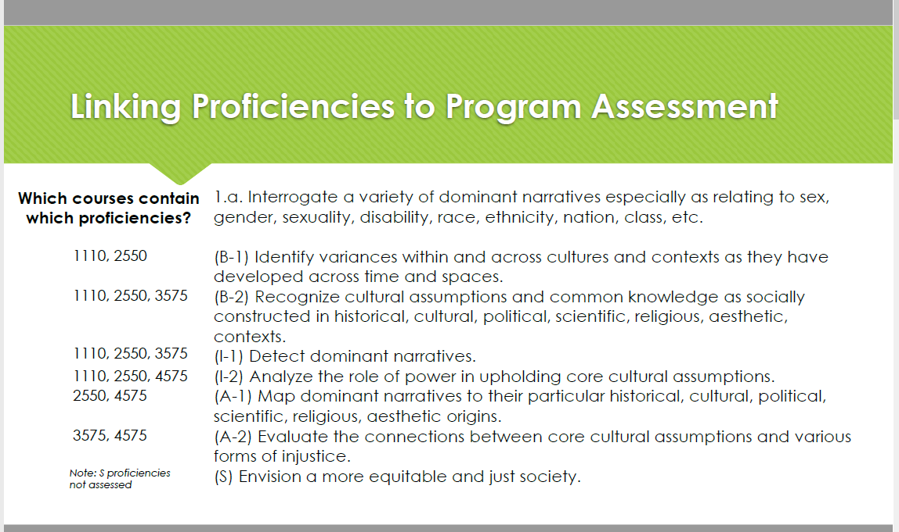 Fig. 1

While ideally we would be able to assess every instance that each proficiency is practiced in each core course, the faculty labor required to do so is beyond our capabilities. Instead, we identified one proficiency at each level and selected one location in a single course to assess during the first assessment cycle (figure 2). Using this method of selection, these representative proficiencies can be varied from cycle to cycle depending on our assessment needs.

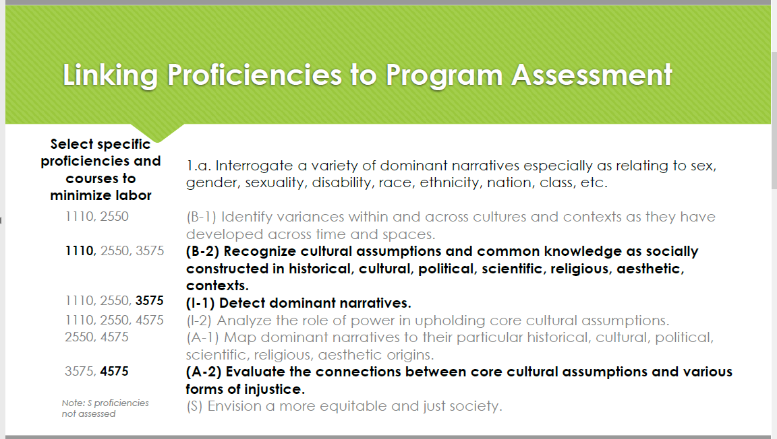 Fig. 2

Out of this approach, we created a plan to assess a total of 38 proficiencies located required courses during year one of the assessment cycle, and 28 proficiencies located in required courses during year two. Figure 3 details the precise representative proficiencies for each year of the cycle, with the exception of elective course proficiencies, which will be determined on a yearly basis.

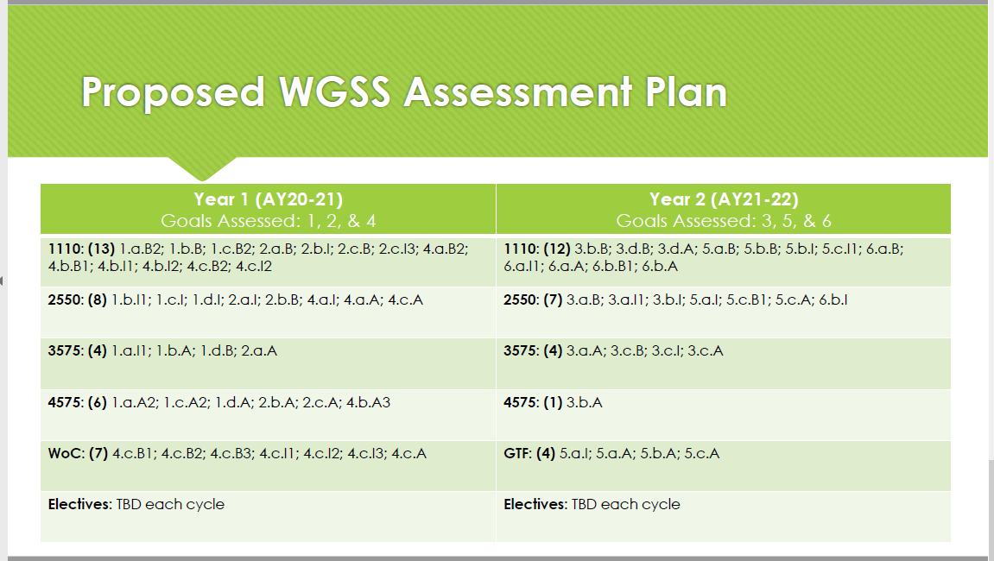 Fig. 3

While 38 and 28 individual proficiencies still may seem to be a large number for assessment purposes, it’s important to note that proficiencies do not correlate to assignments assessed on a one to one basis. Based on current estimations, we anticipate a two to one ratio of proficiencies to assignments. Figure 4 details these projections, which will greatly reduce the number of individual assignments a faculty member will be asked to review per semester.

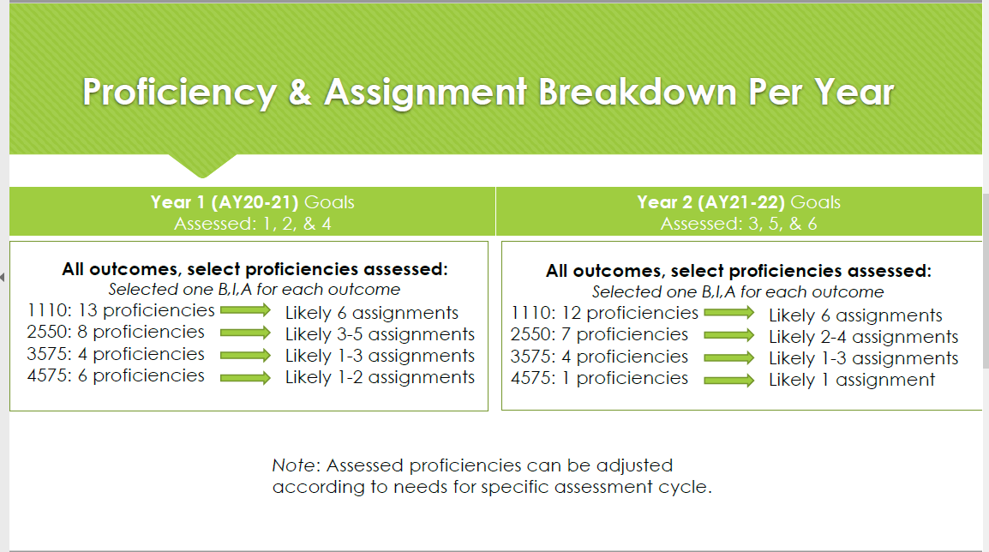 Fig. 4

Timelines for Data Collection and Analysis
Faculty members teaching core courses will be asked to submit assessment data in January following Autumn semester and in May following Spring semester. The Chair of the Undergraduate Studies Committee, with the assistance of the Program Coordinator, will combine and perform an initial analysis of the data for submission to ASC college assessment in July. When the UGSC reconvenes, a full data review will occur at the first meeting in September. In October, UGSC will present the findings of the assessment data to the faculty, along with any recommendations or calls to action based on the findings.

Criteria for Success
Our primary marker of success is for a majority of our students to earn a four out of five, or “above average” on a Likert scale, in each proficiency the encounter in a course with expectations for the percentage of students we aim to hit this marker varying based on course level. Under our new curriculum plan course level should roughly correspond to the number of basic, intermediate, advanced, and specialized proficiencies that are emphasized in each course. For example, a 1000- or 2000-level course should feature mostly basic proficiencies, some intermediate proficiencies, and few advanced proficiencies. Conversely, a 4000-level course should have few basic proficiencies, while concentrating on intermediate and advanced proficiencies. In accordance with class level, we do not anticipate as many students will be successful in hitting the above average mark for the intermediate and advanced proficiencies that appear in lower level courses. Thus expectation on the percentage of a class we wish to achieve an above average designation scales according to class level. This level is noted in figure 5 (also Appendix J) as the “goal” percentage. Similarly, the level at which we become concerned that a class is not demonstrating adequate proficiency scales within each class based on proficiency level and overall based on class level. The minimum marker of success is noted in figure 5 as the “flag” level. Particular attention will be paid to courses where the percentage of students demonstrating above average proficiency fall below this “flag” level.

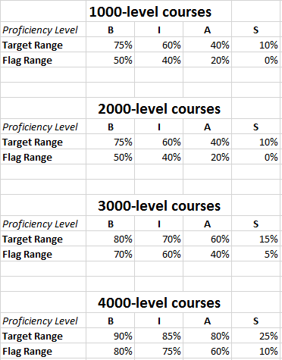Fig. 5

Rubrics to determine what an above average score look like will be developed on a rolling basis as a collaboration between faculty and the Undergraduate Studies Committee. As faculty review student assignments for assessment purposes, they will provide samples of the differing levels of the rubric scale. These examples can then be turned into a repository for faculty looking for comparison points of what makes a one versus a five on a rubric.

Continued Use of Assessment Data
Moving forward assessment data will be used to evaluate the goals, outcomes, and proficiencies of the program in addition to recommendations to teaching protocols. As an example from the recent assessment of WGSST 1110, the Undergraduate Studies Committee noted that students are demonstrating poorer-than-anticipated writing skills. A recommendation for faculty consideration is a writing workshop day in faculty-led classes, along with an emphasis on utilization of the writing center and other campus resources across all WGSS classes.

